



**Site Audit**

**www.**

**Webpulav.in**

**19-12-2018**

# TABLE OF CONTENTS

TABLE OF CONTENTS **.......................................................................................................................... 2**

EXECUTIVE SUMMARY **........................................................................................................................ 4**

BREAKDOWN OF ISSUES **...................................................................................................................... 5**

## 1.0 Content **................................................................................................................................................5**

1.1 Issues ............................................................................................................................................................5

1.2 Recommendations .......................................................................................................................................6

2.0 Crawl **....................................................................................................................................................8**

2.2 Recommendations .................................................................................................................................... 11

3.0 Sitemap **.............................................................................................................................................. 12**

3.1 Issues ......................................................................................................................................................... 12

## 4.0 Robots.txt **........................................................................................................................................... 13**

4.1 Issues ......................................................................................................................................................... 13

4.2 Recommendations .................................................................................................................................... 14

## 5.0 Canonicalization **.................................................................................................................................. 14**

5.1 Issues ......................................................................................................................................................... 14

5.2 Recommendations .................................................................................................................................... 15

## 6.0 Architecture **........................................................................................................................................ 16**

6.1 Issues ......................................................................................................................................................... 16

6.2 Recommendations .................................................................................................................................... 17

7.0 Internal Links **....................................................................................................................................... 18**

7.2 Recommendations .................................................................................................................................... 19

## 8.0 Inbound Links **...................................................................................................................................... 21**

8.1 Issues ......................................................................................................................................................... 21

8.2 Recommendations .................................................................................................................................... 22

## 9.0 Images **................................................................................................................................................ 23**

9.1 Issues ......................................................................................................................................................... 23

9.2 Recommendations .................................................................................................................................... 24

## 10.0 Titles **................................................................................................................................................. 25**

10.1 Issues ....................................................................................................................................................... 25

10.2 Recommendations .................................................................................................................................. 26

## 11.0 Meta Descriptions **.............................................................................................................................. 27**

11.1 Issues ....................................................................................................................................................... 27

11.2 Recommendations .................................................................................................................................. 27

12.0 Site Speed **......................................................................................................................................... 29**

12.1 Issues ....................................................................................................................................................... 29

12.2 Recommendations .................................................................................................................................. 30

13.0 Conclusions **....................................................................................................................................... 31**

# EXECUTIVE SUMMARY

Detailed here is a 100-foot view of the issues identified in the [webpulav.in] site with some priority values.

If you follow any of the links to pages deeper in this document, simply press F5 or Ctrl-G and enter 5 to navigate back to the Executive Summary (which normally falls on page 5).

I sometimes provide links to reports from Google Analytics and/or Webmaster Tools, so it would be a good idea to log in to these in your default browser (in other words, the one that Word automatically opens when you click on a link from a Word document). If you have a personal or other professional Gmail/Google Apps login, you may want to log out of it in your default browser and use a secondary browser.

# BREAKDOWN OF ISSUES

## 1.0 Content

[page is largely optimized for SEO performance. SEO optimization is important to ensure you can maximize ranking potential and drive traffic to your website from search engines. You can continue to build on your position by ensuring On and Off-Page factors highlighted here are improved, as well as through application of SEO strategies like content generation and link building.Content are the important factor of SEO as it help in achiving ranking ,it includes of keyword of website and title tag which help it achiving good ranking]

### 1.1 Issues

Site contains “thin” pages

[Your page has a low volume of text content which search engines can interpret as 'thin content'. It has been well researched that higher text content volumes are related to better ranking ability in general.

Word Count: 125]

#### Pages with content duplicated on other pages

[No duplicate content]

#### Pages with missing H1 tags

[page is making good use of header tags.]

|  |  |
| --- | --- |
| H1 | WebPulav.in |
| H1 | Free Marketing tips of Online Marketing |
| H2 | News |
| H3 | How to perform keyword research for SEO |

Search engines use the H1 tag to interpret what a page is about, much the same way readers of a magazine use article titles to get an idea of what an article is about. When pages are missing H1 tags, it’s harder for both visitors and search engines to decipher what the page is about. The H1 tag should contain a *judicious* use of the keyword(s) you’re targeting. Be careful to make the language natural and do not engage in keyword stuffing. If you have to decide between user experience and SEO, go with user experience.

Pages contain multiple H1s

[

|  |  |
| --- | --- |
| H1 | WebPulav.in |
| H1 | Free Marketing tips of Online Marketing |

]

#### Site contains obtrusive ads

[NO ads]

### 1.2 Recommendations

* Execute a link building Strategy
* Use the main keyword across important HTML tags
* Encourage Page Social Sharing

2.0 Crawl

[crawling is a type of bot of any search engine which comes to your site to index it]

2.1 Issues

### Dips in crawl rate

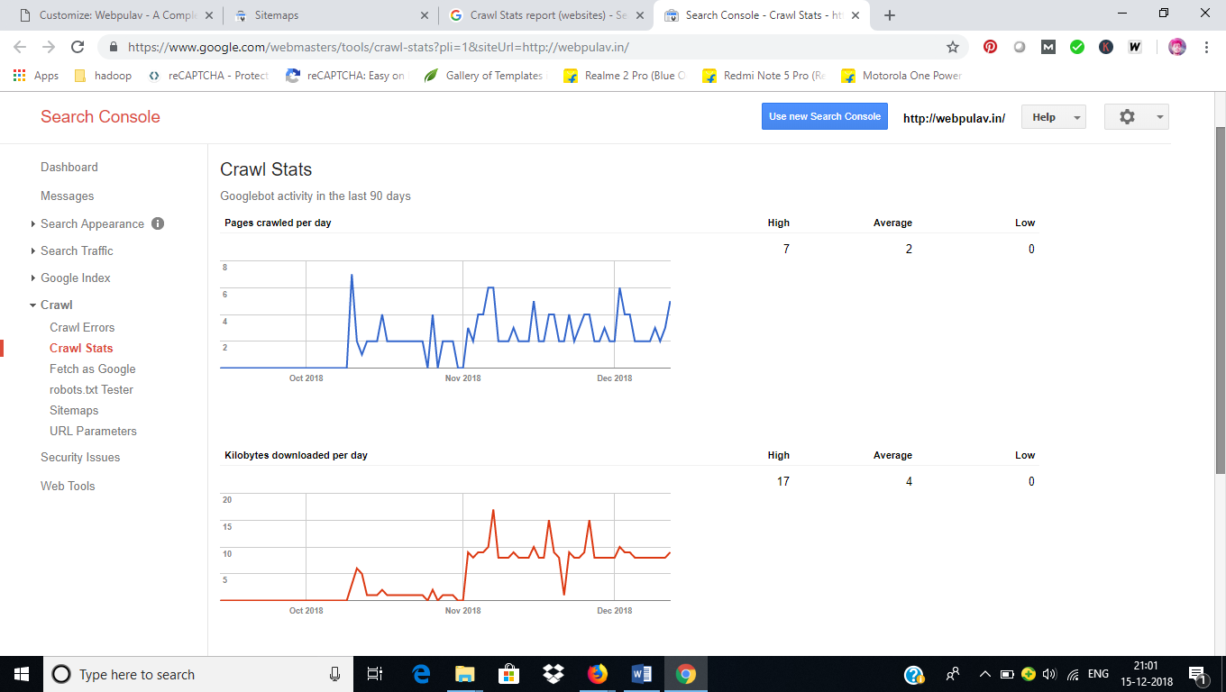

GWT Indexed Pages

You can get more details by clicking the Advanced tab:

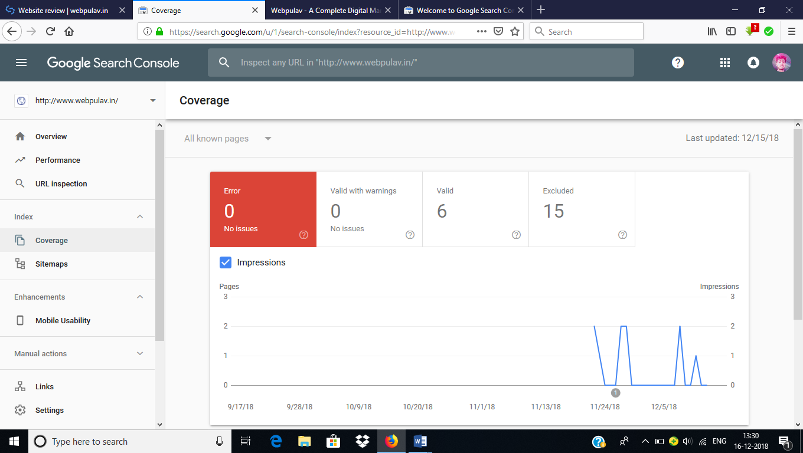

No custom 404 page

[Not Found]

404 pages are trending upward

[2]

### 404 pages aren’t configured properly

|  |  |  |  |  |
| --- | --- | --- | --- | --- |
|  | 1 | contact-us-2/ | 404 |  |
|  | 2 | category/uncategorized/ | 404 |  |

Site pages are returning server errors

[Not found]

Server errors are trending upward

[No error detected in last 90 days]

### Server is denying search engines access to URLs

[No error detected in last 90 days]

The robots meta tag would go in the <head> section of the page and look like this on [WHATEVER PAGES SHOULD BE BLOCKED] pages:

<META NAME="ROBOTS" CONTENT="NOINDEX, FOLLOW">

### Paginated URLs without the rel=”next” and rel=”prev” tags

[NO Issue]

In case you identify that the site is showing the same content with paginated URLs without adding the rel=”next” and rel=“prev” tag to the pages, indicate that this problem must be fixed. Explain your recommendations to enhance this aspect by giving examples with screenshots.Look to see if paginated pages are getting organic traffic (by looking for URL patterns). Pay attention to see if they’re cannibalizing other, more important pages.

[NO Issue]

### Site uses nofollow tags ineffectively

[NO Issue]

### Navigation uses Javascript

[NO Issue]

## 3.0 Sitemap

### 3.1 Issues

[NO issue]

#### No XML Sitemap for the site

[Sitemap Found]

#### Sitemaps not submitted to Google

|  |
| --- |
| [http://www.webpulav.in/sitemap_index.xml |
| http://webpulav.in/sitemap_index.xml] |

Submitted

#### Errors in XML sitemap

[NOT FOUND]

#### No HTML Sitemap

[NOT FOUND]

#### Blocked pages in sitemap

[NOT FOUND]

## 4.0 Robots.txt

[User-agent: *

Disallow: /wp-admin/

Allow: /wp-admin/admin-ajax.php]

### 4.1 Issues

#### Missing Robots.txt file

[NOT FOUND]

#### Pages that should be in robots.txt

[All pages in robot.txt]

No Sitemaps XML declared in Robots.txt

[Not Found]

Blocked pages in Robots.txt that shouldn’t be blocked

[Not Found]

Errors in Robots.txt

[No error]

## 5.0 Canonicalization

[There is no problem in website pages related to canonicalization]

### 5.1 Issues

Homepage not canonicalized properly

[No issue]

#### Non-www & /index.html versions of the URLs not 301-redirected

[No issue]

#### Parameter URLs creating duplicate content

[No issue]

#### IP doesn’t canonicalize

[NO issue]

Site doesn’t canonicalize print pages

[NO issue]

## 6.0 Architecture

[Architecture of website is good as architecture is a ranking factor of seo.]

### 6.1 Issues

#### Issues with directory structure

[NO issue]

#### Non-hierarchically organized URLs

[URLs are organised in hierarchically manner]

#### Breadcrumb Issues

[No breadcrumb issue only there is no breadcrumb navigation in every pages of website]

Dynamic URLs

[yes] Search for a question mark in organic landing pages

#### Non-descriptive URLs

[NO issue]

Broken links throughout the site

[No broken links found]

## 7.0 Internal Links

[Site have 7 internal links which go from one page to other page]

7.1 Issues

### Site doesn’t link to pages with highest authority

[No issue found]

Step 1: Run Top Pages report from Open Site Explorer and download the csv:

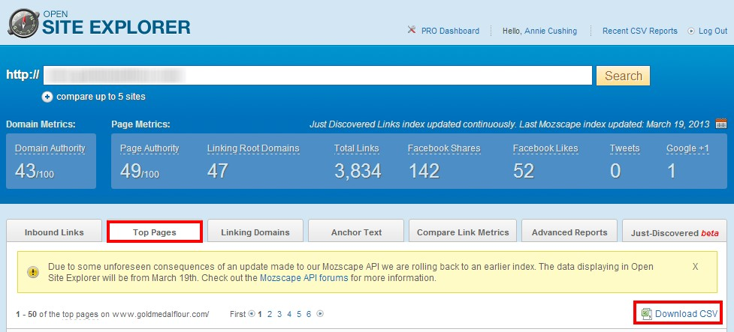

Step 2: Pull internal links from GWT: Search Traffic > Internal Links:

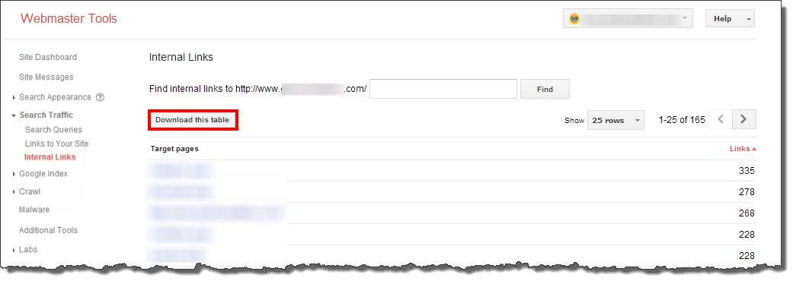

### Site has links that can’t be crawled or followed

NO Issue found identify links that can’t be crawled or followed on the site, indicate which sections or pages need to fix this problem. Explain your recommendations to enhance this aspect by giving examples with screenshots.

### Pages in the site pointing to 404 pages

[No issue] Screaming Frog: Take the list of 404 pages, scan them as a list, and look at Inlinks (one of the tabs at the bottom) for key pages.

### Pages with too many links

[no there are not too many links in any page] Screaming Frog: Internal tab > Outlinks column (not External Outlinks). Reorder so that the pages with the most links are at the top of the table. Do any of them include more than 100 links? Is so, export the Internal tab and filter in Excel to show only pages with > 100 links and add that worksheet to the Audit Data workbook.

### 7.2 Recommendations

NO Recommendations

## 8.0 Inbound Links

[Inbound links are those link which come from another site to your site , it can be called as backlink type because it passes authority with it]

### 8.1 Issues

#### Overly optimized and repetitive anchor text

The current best practice is to have 15-30% of your overall link profile coming from exact or nearmatch anchor text links. The remainder of the links typically use a mixture of brand terms, naked URLs, and junk links (e.g., click here, here, no anchor at all).

[No inbound link] Create word cloud of anchors. http://wordle.net

#### Decline in inbound links

[No inbound link found]

Check ahrefs.com: Enter URL, scroll down to Backlinks graph Example:

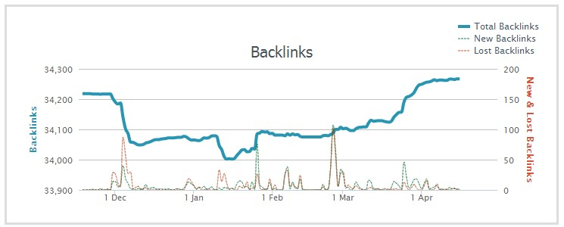

[/NO inbound link found]

#### Best linkable assets

[No inbound link found]

OSE: Top Pages tab

Majestic: Pages tab

GWT: Traffic > Links to Your Site > Your most linked content

Linkable assets aren’t top organic landing pages

[No inbound link found] Look to see if best linkable assets coordinate with top landing pages.

#### Links to non-canonical URLs

[NO issue] In case you identify internal links to non-canonical URLs on the site, indicate which sections or pages need to fix this problem. Explain your recommendations to enhance this aspect by giving examples with screenshots.

Site missing Yahoo Directory link(s)

[NO issue] http://www.domaintools.com/: Site Profile tab.

### 8.2 Recommendations

* No recommendations

## 9.0 Images

[Images should contain alt text as crawler can not read images ,but they can read alt text of images]

### 9.1 Issues

#### Large images

[Images are optimized,no issue]

With SEO being inextricably tied to user experience, search engines are trying to motivate webmasters to make their sites easier to use by adding page load time as a ranking factor. (Learn more in the Site Speed section of the audit.) One factor that can bloat page load times is large images. In the rush to publish, it’s easy to overlook image size. However, great care should be taken to make sure images are under 100KB (and even smaller if you have an entire page of images).

#### Images with no or irrelevant ALT text

[No issue found] Screaming Frog: Advanced Export menu > Images Missing ATL Text and All Image ALT Text.

Images with irrelevant file names

[No issue found]

No image sitemap

[Every image has sitemap,no issue]

#### Image sitemap contains errors, is incomplete, or isn’t submitted to search engines

[Not found] In case you identify that the site is not featuring an image XML Sitemap, that it hasn’t been verified through GWT, that it’s showing errors, is incomplete, or not fresh, indicate it and explain your recommendations to enhance this aspect by giving examples with screenshots. Specify the consequnces if it’s not optimized.

#### Visibility for image search

[No issue] GWT: Search Traffic > Search Queries > Filters > Filter by images

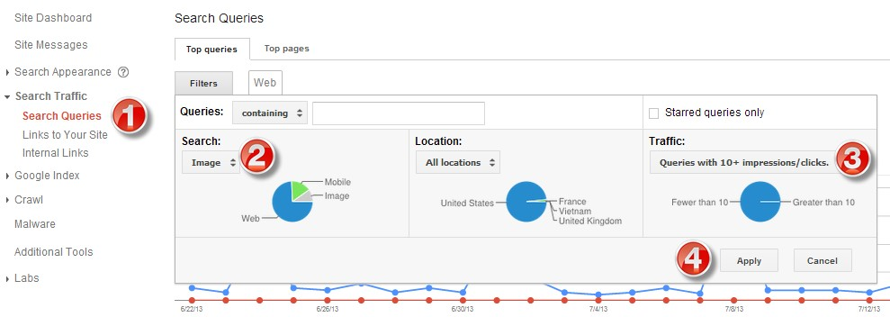

### 9.2 Recommendations

* No Recommendation

## 10.0 Titles

[titles contain keyword about content and they are very important as per seo]

### 10.1 Issues

Pages with missing titles

[Not found]

#### Pages with long titles

#### [ not found]

It’s recommended that a site keep page titles under 55 characters. You can find them in the Audit Data workbook under the Long Page Titles tab.

#### Pages with short titles

[ every page contain the title between 10-70 char as per seo]

[CLIENT] has a number of pages with page titles that are shorter than 30 characters, which Google flags as a short title. Many of them are pages that should be blocked from the search engines anyway, as recommended here. I recommend focusing on the non-highlighted URLs. Duplicate page titles

#### Odd capitalizations in titles

[Not found]

Page titles typically use title case. Whatever case you choose to use, you should keep it consistent. Capitalizing words just to emphasize them makes your page titles unattractive and distracting.

#### Pages with irrelevant, non-optimized, or non-descriptive titles

[No issue] Use this [GA custom report with landing pages and page titles](http://bit.ly/Z8NGtk) to prioritize which page titles should be optimized first.

Since the page title is arguably the most important piece of real estate as far as SEO goes, writing titles that are both optimized and compelling is critical to both ranking and click-throughs. Titles like the ones below don’t take advantage of the power the [CLIENT] team has to get its message out to a broader audience:

[no poor page title found]

### 10.2 Recommendations

* No Recommendation

## 11.0 Meta Descriptions

[Meta description are those which appear in google search to user and it is information provided by you for meta tag of your site otherwise google randomly pick it up from your site]

### 11.1 Issues

#### Pages with missing meta descriptions

#### [ Not Found ]

The Missing Meta Descriptions tab of the Audit Data spreadsheet contains pages that are missing meta descriptions. If [CLIENT] decides to block the pages that should be blocked from the search engines here [LINK], those pages will not need to be prioritized.

#### Pages with long meta descriptions

[ every pages have ideal length of meta description ]

The Long Meta Descriptions tab of the Audit Data workbook lists pages that have long meta descriptions. Long descriptions will be truncated, reducing their readability.

#### Pages with short meta descriptions

[ every pages have ideal length of meta description ]

The Short Meta Descriptions tab of the Audit Data workbook lists pages that have short meta descriptions, which Google flags at 69 characters.

#### Odd capitalizations in descriptions

[ not found ]

Meta descriptions should be written with a conversational tone that follows standard sentence case to aid readability.

#### Descriptions missing power calls to action

[No issue] Pay special attention to homepage, category pages, and product/content pages. Alternatively, pull in titles and descriptions of top landing pages.

### 11.2 Recommendations

* No Recommendation

## 12.0 Site Speed

[Site speed is one of the important factor of seo as it is the site load time for a user ]

### 12.1 Issues

High Page Load time

[No issue]

#### Site not using gzip compression

The [CLIENT] site does not appear to be using gzip compression. You should [compress your HTML](http://www.seositecheckup.com/articles/85) to reduce your page size and page loading times. This will help your site retain visitors and increase pageviews. Consider using [GZIP](http://betterexplained.com/articles/how-to-optimize-your-site-with-gzip-compression/) to compress your HTML. The GTMetrix report for the [CLIENT] site contains specific resources it recommends for gzip compression; this will reduce the transfer size of the files listed by [X]%.

[Site is using gzip compression] Use [SEO SiteCheckup](http://www.seositecheckup.com/) to check.

#### Site uses inline CSS

Inline styles are CSS styles that are specified within the page code itself, as opposed to inside an external style sheet. Repeated use of inline styles leads to unnecessary code bloat and slower page loading. Using an [external CSS stylesheet](http://www.seositecheckup.com/articles/107) that references these styles will lead to smaller code and faster page loading.

[site is using inline CSS] Use [SEO SiteCheckup](http://www.seositecheckup.com/) to check.

#### Site uses inline Javascript

[Not found]

If your site is using the same Javascript code across multiple pages, you should consider using an external Javascript file so that it will be cached by the user's browser for each of those page views. This will reduce your page's HTML size, as well as make your code easier to maintain.

#### Site doesn’t minify JavaScript or CSS

[No issue]

The [CLIENT] site doesn’t minify — or compress — its JavaScript or CSS files. Minifying these files removes unnecessary bytes on the wire. While it's great to put comments, tabs and whitespace in code to improve readability and maintenance, these are bytes that take up space on the wire and that a browser has to parse unnecessarily. Minifying the site’s JavaScript resources could reduce their size by X%. You can get a full list of JavaScript files from the GTMetrix report for the [CLIENT] site [LINK TO REPORT].

There are free resources online that will minify your JavaScript and CSS files.

#### More recommendations from GTMetrix report / WebPagetest.org

You can view more recommendations to reduce page load time from the GTMetrix report for the [CLIENT] site [LINK TO REPORT].

### 12.2 Recommendations

* Remove inline style sheet

## 13.0 Conclusions

[conclusion of the site is that site is good in many parts of seo and it is also not qualify many criteria required for seo as inbound link and it has inline style sheet and website don’t have SSL certificate]

### Explanation of Priorities or Problems

* Thin content is found
* No backlink
* Missing SSl certificate
* No breadcrumb navigation
* No social media link found on site
* Inline style sheet found